Voice Based Concept Understanding Analyser

Project Description:
The Voice-Based Concept Understanding Analyser (VBCUA) is an AI-powered educational assessment platform designed to evaluate a student's conceptual understanding through spoken explanations. The application combines speech-to-text transcription, semantic similarity analysis, audio signal processing, and AI-based scoring to assess both conceptual knowledge and communication effectiveness.
Built using Python and Streamlit, the platform integrates OpenAI Whisper for speech recognition, Sentence-BERT for semantic similarity, Librosa for audio feature extraction, Matplotlib for waveform visualization, and ReportLab for automated PDF report generation. The system provides an interactive dashboard that displays transcription, waveform visualization, semantic similarity score, filler word analysis, pause ratio, confidence level, final understanding score, and personalized feedback.
The application serves as an intelligent educational tool for students, educators, trainers, and researchers, helping users improve conceptual knowledge, communication skills, and presentation confidence.

Scenarios

Scenario 1: Semantic Understanding Evaluation
A student uploads an audio explanation of a concept such as Machine Learning, Cloud Computing, or Artificial Intelligence. The system transcribes the speech using OpenAI Whisper and compares the explanation with a predefined reference concept using Sentence-BERT semantic embeddings. Based on semantic similarity, the application evaluates conceptual understanding and classifies the result as Strong Understanding, Moderate Understanding, or Poor Understanding.
Scenario 2: Speech Fluency and Communication Analysis
A learner preparing for interviews or presentations records a spoken explanation. The application analyzes speech fluency using filler word detection, pause ratio analysis, RMS energy, and audio signal processing through Librosa. The generated feedback helps users improve confidence, articulation, speaking clarity, and overall communication skills.
Scenario 3: Interactive Performance Reporting
After analysis, the application displays an interactive dashboard containing the transcribed explanation, waveform visualization, semantic similarity score, communication metrics, confidence level, and final evaluation score. Users can download a professionally formatted PDF report containing detailed analysis and AI-generated feedback for academic assessment and future review.

Technical Architecture:

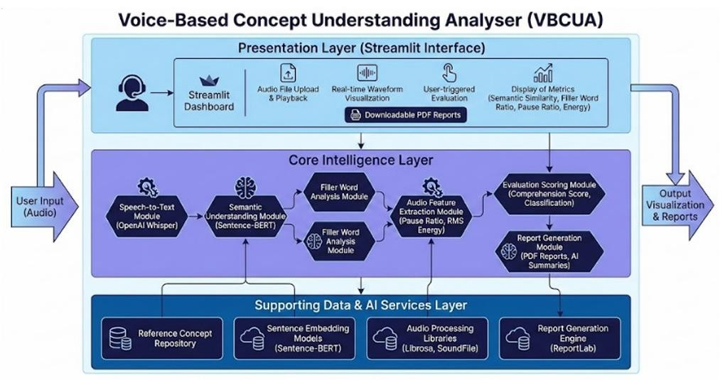
Description: The Voice-Based Concept Understanding Analyser follows a modular AI-driven architecture that integrates speech recognition, semantic analysis, audio processing, scoring, and reporting into a single educational assessment platform.
The Streamlit frontend allows users to upload voice recordings and visualize evaluation results. The backend uses OpenAI Whisper for speech transcription, Sentence-BERT for semantic similarity computation, Librosa for extracting speech features, and Python-based scoring algorithms to evaluate conceptual understanding. Matplotlib generates waveform visualizations, while ReportLab creates downloadable PDF reports. The modular architecture ensures scalability, maintainability, and efficient AI-based evaluation.
Pre-requisites:
Python 3.10+ : https://docs.python.org/3/ ⁠
Streamlithttps : //docs.streamlit.io/ ⁠
OpenAI Whisperhttps : //github.com/openai/whisper ⁠
Sentence-Transformers (Sentence-BERT) : https://www.sbert.net/ ⁠
PyTorch (Torch)https : //pytorch.org/docs/stable/index.html ⁠
Librosahttps : //librosa.org/doc/latest/index.html ⁠
NumPyhttps : //numpy.org/doc/ ⁠
Matplotlibhttps : //matplotlib.org/stable/users/index.html ⁠
ReportLabhttps : //www.reportlab.com/documentation/ ⁠
SoundFilehttps : //python-soundfile.readthedocs.io/ ⁠
Githttps : //git-scm.com/doc ⁠
GitHubhttps : //docs.github.com/ ⁠
Visual Studio Codehttps : //code.visualstudio.com/docs ⁠

Project Workflow:

Milestone 1: Model Selection and Architecture
- Activity 1.1: Install and Configure Required Libraries
- Activity 1.2: Research and Select the Appropriate AI Models
- Activity 1.3: Define the Architecture of the Application
- Activity 1.4: Set Up the Development Environment

Milestone 2: Core Functionalities Development
- Activity 2.1: Develop Speech-to-Text Transcription Module
- Activity 2.2: Implement Semantic Similarity Analysis
- Activity 2.3: Develop Audio Feature Extraction Module
- Activity 2.4: Build Concept Evaluation and Scoring Engine

Milestone 3: App.py Development
- Activity 3.1: Develop Streamlit Application
- Activity 3.2: Integrate AI Processing Pipeline
- Activity 3.3: Implement PDF Report Generation

Milestone 4: Frontend Development
- Activity 4.1: Design the User Interface
- Activity 4.2: Implement Dynamic Content Rendering
- Activity 4.3: Display Evaluation Results
- Activity 4.4: Enable Report Download

Milestone 5: Deployment
- Activity 5.1: Prepare the Application for Local Deployment
- Activity 5.2: Local Testing and Verification
- Activity 5.3: Deployment Preparation
Milestone 6: Conclusion

Milestone 1: Model Selection and Architecture
In this milestone, we focus on selecting the appropriate AI models and audio-processing tools for the Voice-Based Concept Understanding Analyser. This involves researching speech-to-text models, semantic similarity techniques, audio feature extraction methods, and report generation libraries to ensure the application accurately evaluates spoken conceptual explanations.

Activity 1.1: Install and Configure Required Libraries
Before the application can process audio and evaluate understanding, all required Python libraries must be installed and configured properly.
- Step 1 —Install Python: Install Python 3.10 or above from the official Python website.

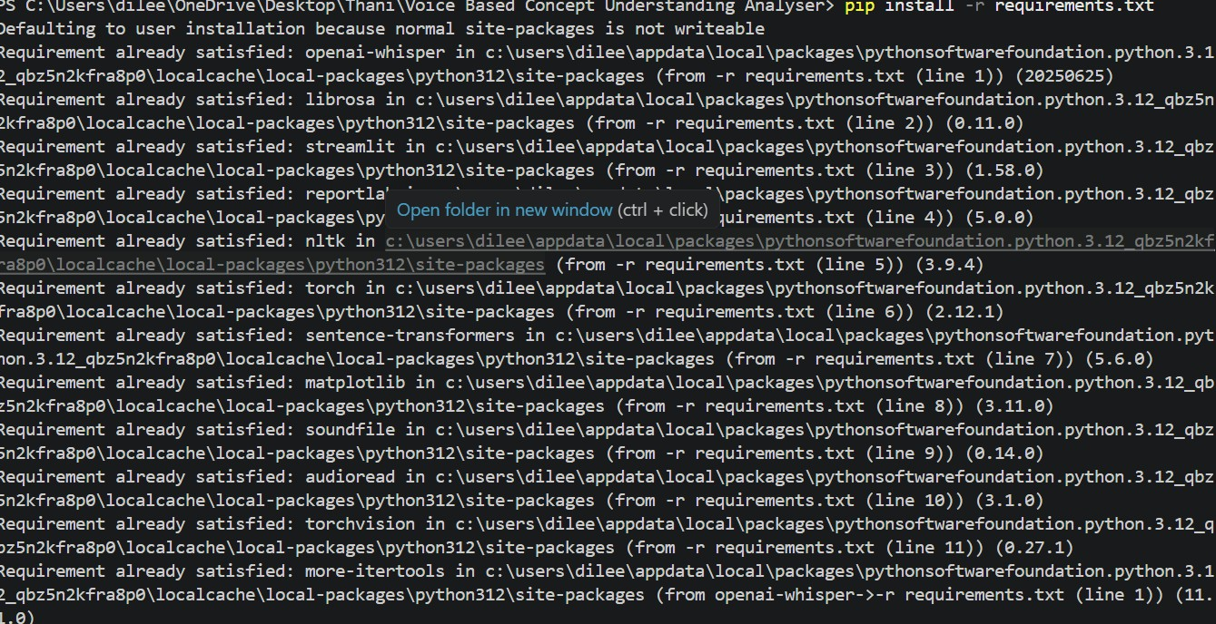

- Step 2 —Create a Virtual Environment: Create a virtual environment to manage project dependencies separately
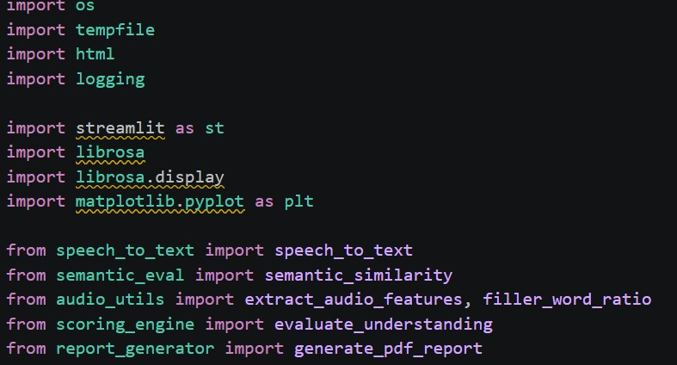

- Step 3 — Install Required Libraries: Install Streamlit, Whisper, Sentence-Transformers, Librosa, Torch, Matplotlib, NLTK, SoundFile, and ReportLab.
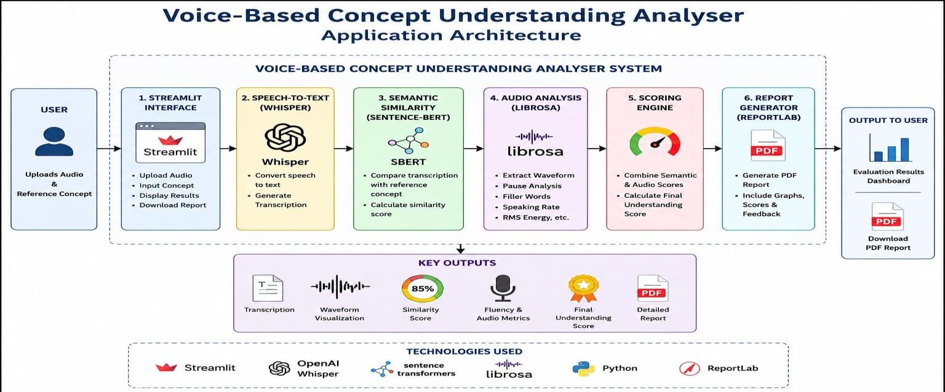

- Step 4 — Verify Installation: Run the project and confirm that all libraries are imported without errors.

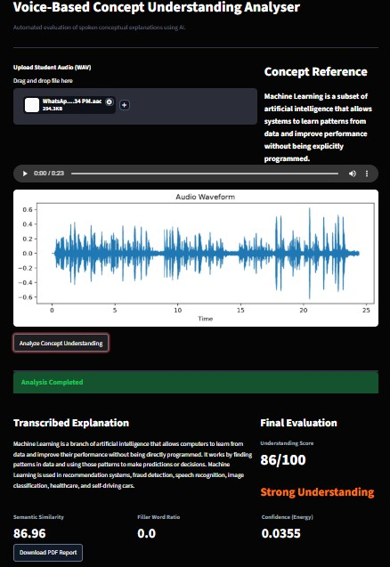

- Step 5 — Run the Application: Start the Streamlit application using streamlit run app.py.

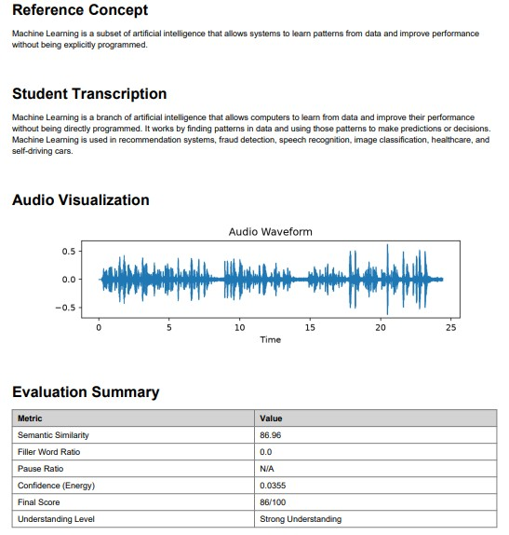

Activity 1.2: Research and Select the Appropriate Generative AI Model
The following technologies were researched and selected based on their accuracy, performance, and suitability for spoken concept evaluation.
Understand the Project Requirements: Analyze the need for speech transcription, semantic understanding, audio feature extraction, and automated educational assessment.
Explore AI Model Documentation: Review the documentation for OpenAI Whisper, Sentence-BERT (all-MiniLM-L6-v2), Librosa, and ReportLab to understand their capabilities and integration process.
Evaluate Model Performance: Compare models based on transcription accuracy, semantic similarity performance, computational efficiency, and support for educational applications.
Select the Optimal Models: Finalize OpenAI Whisper for speech-to-text transcription, SentenceBERT for semantic similarity evaluation, Librosa for audio signal analysis, and ReportLab for PDF report generation.

Activity 1.3: Define the Architecture of the Application
Design the System Architecture: Create a modular architecture consisting of the Streamlit frontend, AI processing modules, evaluation engine, and PDF report generator.
Define Frontend Workflow: Design an interface that allows users to upload audio, view waveform visualization, analyze conceptual understanding, and download evaluation reports.
Develop Backend Modules: Implement modules for speech transcription, semantic similarity calculation, audio feature extraction, scoring engine, and report generation.
Integrate AI Components: Connect OpenAI Whisper, Sentence-BERT, Librosa, Matplotlib, and ReportLab to build a complete AI-powered evaluation pipeline.

Activity 1.4: Set Up the Development Environment
Set up the Python environment and project structure required to run the Voice Based Concept Understanding Analyser application.
- Install Python and Pip: Ensure Python 3.10+ is installed along with pip for package management.
- Create a Virtual Environment: Create a separate virtual environment to manage project dependencies safely.
python -m venv venv

- Activate the Virtual Environment:
venv\Scripts\activate
- Install Required Libraries: Install all project dependencies from the requirements file.
pip install -r requirements.txt
- Set Up Application Structure: Organize the project files into separate modules for transcription, semantic analysis, audio processing, scoring, and report generation.
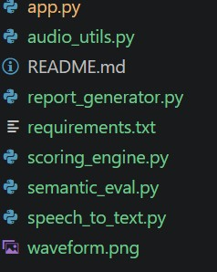

Milestone 2: Core Functionalities Development

Activity 2.1 Develop Speech-to-Text Transcription Module
- Implement speech transcription using OpenAI Whisper.
- Accept uploaded WAV audio files.
- Convert speech into accurate text.
- Handle different accents and background noise.

Activity 2.2: Implement Semantic Similarity Analysis
- Compare the student's explanation with the reference concept.
- Generate semantic similarity using Sentence-BERT.
- Measure conceptual understanding accurately.
- Produce similarity score for evaluation.

Activity 2.3: Develop Audio Feature Extraction Module
- Extract waveform using Librosa.
- Calculate filler word ratio.
- Measure pause ratio and RMS energy.
- Analyze communication confidence.

Activity 2.4: Build Concept Evaluation and Scoring Engine
- Combine transcription, semantic similarity, and audio features.
- Calculate the final understanding score.
- Classify performance as Strong, Moderate, or Poor Understanding.
- Generate structured evaluation results and PDF report.

Milestone 3: App.py Development
Milestone 3 focuses on developing the main application file app.py, which connects all core modules of the Voice-Based Concept Understanding Analyser. This file handles the Streamlit interface, audio upload, reference concept input, transcription, semantic similarity analysis, audio feature extraction, scoring, waveform display, and PDF report generation.Activity 3.1: Writing the Main Application Logic in app.py

Activity 3.1: Develop Streamlit Application
- The main Streamlit application is developed in app.py. It provides the user interface where users
- can upload audio, view the reference concept, listen to the uploaded recording, and start the
- analysis process.
- Create the application title and description.
- Add audio file upload option.
- Display the reference concept section.
- Show uploaded audio playback.
- Provide the Analyze Concept Understanding button.

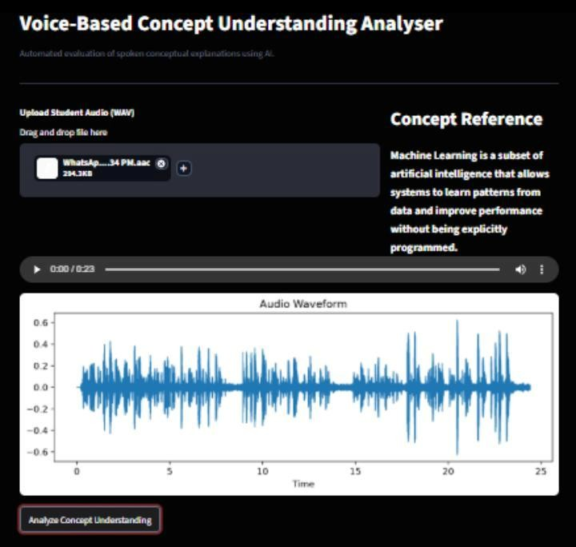

Activity 3.2: Integrate AI Processing Pipeline
- The AI pipeline is integrated inside app.py by connecting transcription, semantic similarity, audio feature extraction, and scoring modules.
- Convert uploaded audio into text using the speech-to-text module.
- Compare transcription with the reference concept using semantic similarity.
- Extract audio features such as filler word ratio, pause ratio, RMS energy, and waveform.
- Calculate final understanding score using the scoring engine.
- Display analysis status and output values on the dashboard.

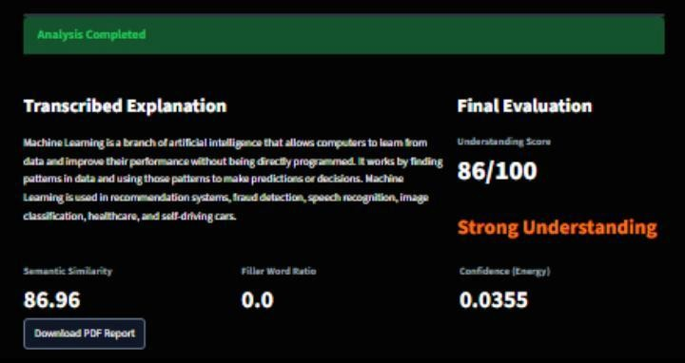

Activity 3.3: Implement PDF Report Generation
- The PDF report generation feature is connected to the main application so users can download their evaluation summary.
- Generate a structured PDF report after analysis.
- Include reference concept, student transcription, waveform visualization, evaluation metrics, final score, and understanding level.
- Provide a Download PDF Report button inside the Streamlit interface.
- Save reports inside the reports folder for future reference.



Verification and Output:
After integrating all modules successfully, the application performs end-to-end processing whenever a user uploads an audio explanation. The uploaded speech is transcribed, evaluated using semantic similarity analysis, and assessed for fluency through audio feature extraction. The scoring engine combines these results to generate the final concept understanding score. The application displays the transcription, waveform, evaluation metrics, and qualitative feedback in the Streamlit interface. Finally, a detailed PDF report containing all analysis results is generated and made available for download, providing users with a complete summary of their performance.

Milestone 4: Frontend Development

Activity 4.1: Designing and Developing the User Interface
Milestone 4 focuses on designing a user-friendly Streamlit interface for the Voice-Based Concept Understanding Analyser. The frontend allows users to upload audio, view the reference concept, analyze speech, display waveform visualization, show evaluation metrics, and download the final PDF report.

Activity 4.1: Design the User Interface
- Create the Streamlit page title: Voice-Based Concept Understanding Analyser.
- Add audio upload option for .wav files.
- Display the reference concept section.
- Add audio playback for uploaded files.
- Add the Analyze Concept Understanding button.

Activity 4.2: Implement Dynamic Content Rendering
- Show waveform automatically after audio upload.
- Display Analysis Completed message after processing.
- Render transcription, scores, and feedback dynamically.
- Update the dashboard based on the uploaded audio file.

Activity 4.3: Display Evaluation Results
- Display student transcription.
- Show semantic similarity score.
- Show filler word ratio, pause ratio, and confidence value.
- Display final score and understanding level.
- Highlight output as Strong Understanding, Moderate Understanding, or Poor Understanding.

Activity 4.4: Enable Report Download
- Generate a PDF report using ReportLab.
- Include reference concept, transcription, waveform, metrics, final score, and feedback.
- Provide Download PDF Report button.
- Allow users to save the report for review.

Frontend Testing and Validation:
The frontend was thoroughly tested to ensure smooth interaction between the user interface and backend processing modules. All interface components, including audio upload, waveform visualization, transcription display, semantic analysis, scoring, and report generation, functioned correctly without errors. Dynamic content updates were verified after each analysis, ensuring users received real-time feedback.
The application was also tested across multiple audio samples to validate responsiveness, accuracy, and usability. The PDF report generation feature successfully exported evaluation results, making the system suitable for academic assessments, concept evaluation, interview preparation, and spoken learning analysis. Overall, the frontend provides an intuitive, responsive, and interactive experience while effectively presenting AI-generated insights and performance metrics.

Milestone 5: Deployment

Milestone 5 focuses on deploying the Voice-Based Concept Understanding Analyser for local testing and public access. This milestone ensures that all required dependencies are installed, the Streamlit application runs successfully, and the project can be securely shared using Ngrok for demonstration and evaluation.

Activity 5.1: Preparing the Application for Local Deployment
- Set Up the Development Environment
- Open the project in Visual Studio Code.
- Create and activate a Python virtual environment.
- Install all required libraries using the requirements.txt file.
- Verify that all project modules and dependencies are installed successfully.
- Configure the project structure and required folders before execution.
Set Up a Virtual Environment:
- Open a New Terminal
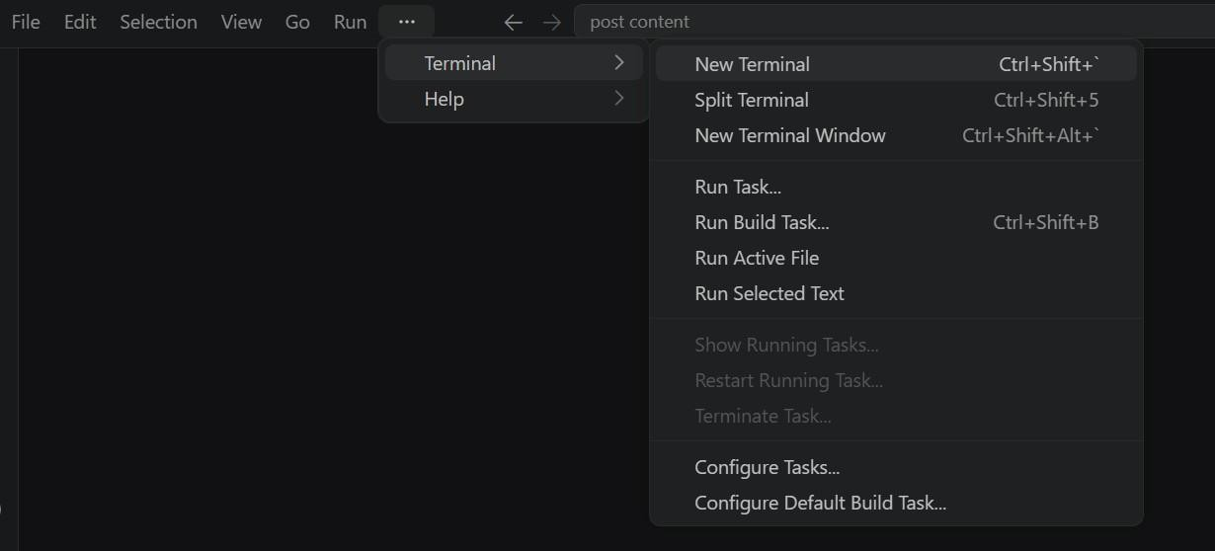
- Then open “Command Prompt”
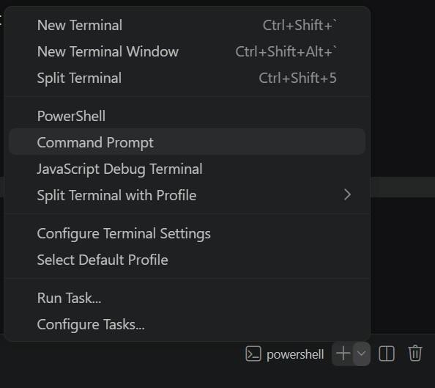

- Create and activate a virtual environment, then install all required dependencies from requirements.
D:\projects>python -m venv myenv
D:\projects>"d:\projects\venv\Scripts\activate"
(myenv) D:\projects>pip install -r requirements.txt

Activity 5.2: Local Testing and Verification
- Launch the Streamlit application using the terminal.
- Open the local Streamlit URL in the browser.
- Upload a sample audio file for testing.
- Verify speech transcription, semantic similarity analysis, waveform visualization, scoring, and PDF report generation.
- Confirm that all application modules execute successfully without errors.
(myenv) D:\projects>python app.py

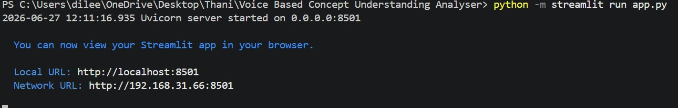

Activity 5.3: Deployment Preparation
- Verified that all required Python dependencies were installed successfully.
- Ensured the Streamlit application was configured correctly for execution.
- Tested the application in the local development environment.
- Verified that speech transcription, semantic analysis, audio feature extraction, scoring, waveform visualization, and PDF report generation worked correctly.
- Prepared the project for future deployment on cloud platforms such as Streamlit Community Cloud, Render, or Ngrok.
D:\projects>pip install pyngrok

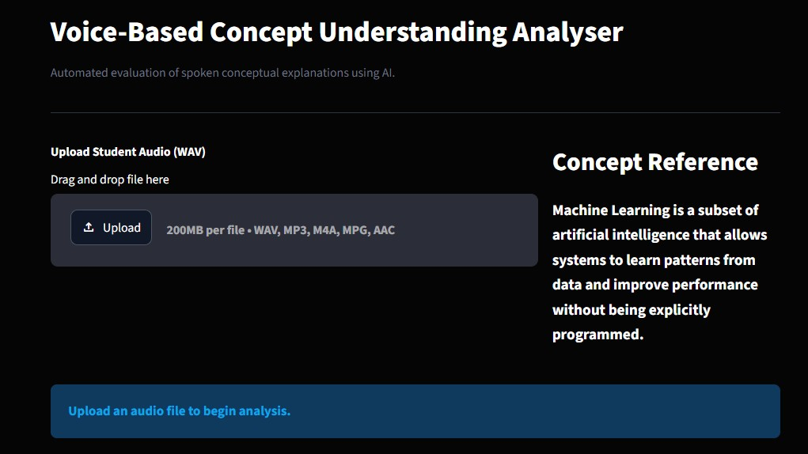

Verification:
The application was successfully executed in the local environment. All core modules functioned as expected, including speech-to-text transcription, semantic similarity analysis, audio feature extraction, intelligent scoring, waveform visualization, and PDF report generation. The project is deployment-ready and can be hosted on a public platform in the future if required.

Exploring the Website’s Web Pages:
Home / Generator Page:

Description: The Home Page serves as the main interface of the Voice-Based Concept Understanding Analyser. Users can upload an audio recording, enter the reference concept, and start the analysis process. The interface is designed using Streamlit to provide a simple, responsive, and user-friendly experience.

Input Section:

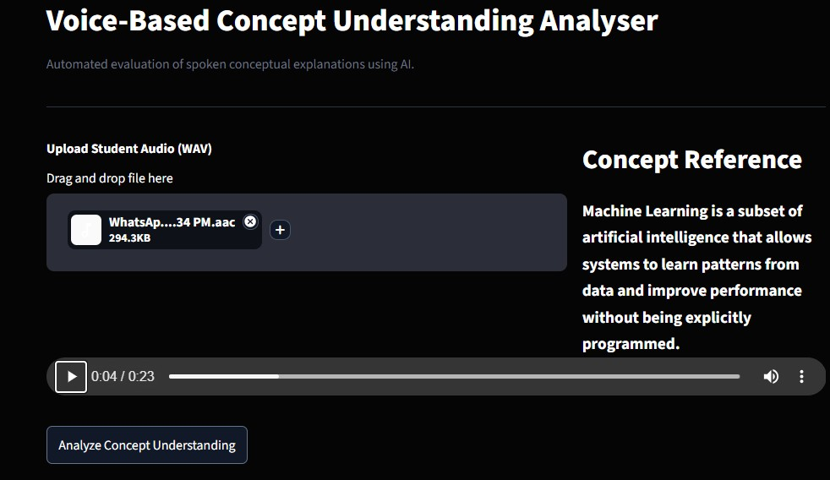
Description: The Input Section allows users to upload a voice recording in WAV format and enter the expected concept or topic. Once the required inputs are provided, the user can initiate the analysis by clicking the Analyze Concept Understanding button.
Results Section:
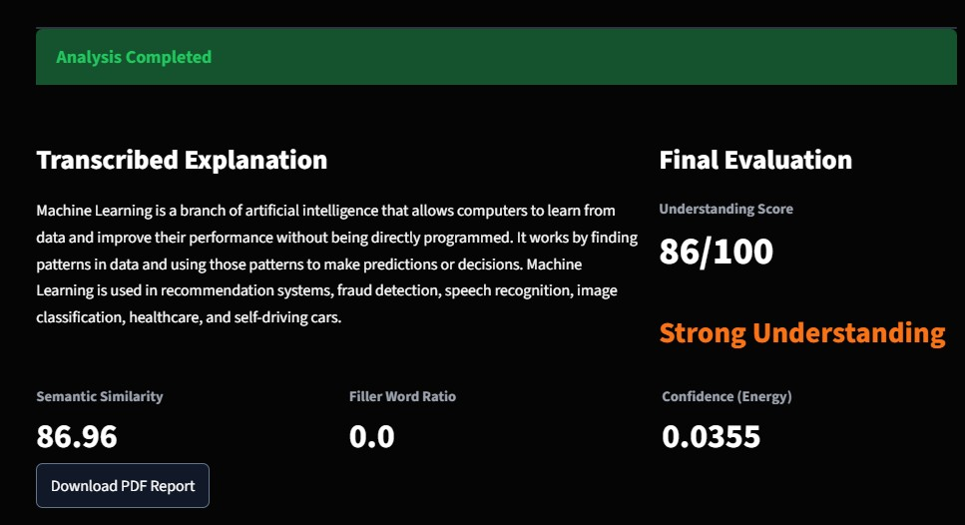
Description: The Results Section displays the generated speech transcription, semantic similarity score, audio feature analysis, waveform visualization, filler word statistics, pause analysis, confidence score, and the final understanding level. These results help users evaluate both conceptual understanding and communication skills.

PDF Report Section:

Description: After the evaluation is completed, the application generates a detailed PDF report containing the transcription, semantic similarity score, waveform image, speech metrics, final evaluation score, and personalized feedback. Users can download the report for future reference or academic assessment.

Conclusion:
The Voice-Based Concept Understanding Analyser (VBCUA) successfully integrates speech-to-text transcription, semantic similarity analysis, audio feature extraction, intelligent scoring, and automated PDF report generation into a single AI-powered educational platform. Built using Streamlit, OpenAI Whisper, Sentence-BERT, Librosa, Matplotlib, and ReportLab, the application provides accurate evaluation of conceptual understanding and spoken communication. The project demonstrates the effective application of Artificial Intelligence, Natural Language Processing, and Audio Signal Processing to create an interactive assessment tool for students, educators, trainers, and researchers. It can be further enhanced by supporting multiple languages, real-time speech analysis, cloud deployment, and personalized learning recommendations.

